**The Final Workbook of**

**Tour and Travel Management System**

# 

# **Group Information:**

**Gayotry Gope Toma**

Student ID: 210212

**Susmita Biswas**

Student ID: 210224

**Jannatul Ferdous Nijhum**

Student ID: 210239

Course: **Information System Design Laboratory**

Course No.: **CSE - 2212**

**Submitted to:**

**Aminul Islam**

Assistant Professor

Computer Science & Engineering Discipline

Khulna University, Khulna.

**Group Information: 1**

**1. The System Service Request(SSR) of the Class Management System 3**

**2. Interview Scripts of the users 5**

2.1 Interview of a teacher 5

2.2 Interview of a resource manager 8

2.3 Interview of a student 12

**3. Baseline Project Plan of Class Management System 17**

3(a). Project Scope Statement of Class Management System 17

3(b). User stories of Class Management System 19

3(c). Use Case Diagram of the Class Management System 33

3(d). Data Flow Diagram of the Class Management System 39

3(e). Entity-Relationship (E-R) Diagram of the Class Management System 43

3(f). Forms, Reports, and Interfaces with Narrative Overview of Class Management System 46

**4. Feasibility Studies of Class Management System 51**

4(a). Economic feasibility analysis & risks and tangible and intangible cost and benefits 51

4(b). Break-even analysis with the proper diagram of the break-even point on a 2D graph. 54

**5. Management Procedure & methodology of Class Management System 55**

**6. Project Charter of Class Management System 56**

**7. Project Schedule with activity list, Gantt chart, PART Analysis, and network diagram of Class Management System 57**

7.1 Activity list 57

**8. Business Documents****59**

**1. System Service Request**

**Tour and Travel Management System**

**System Service Request**

**REQUESTED BY:** Susmita Biswas **DATE:** 10.09.22 **LOCATION:** Gollamari, Khulna

**CONTACT:** 01771958540

**TYPE OF REQUEST** **URGENCY**

✓ New System ☐ Immediate: Operations are impaired

☐ System Enhancement ✓ Problem exists, but can be worked around

☐ System Error Correction ☐ Business losses can be tolerated until new

system installed

**PROBLEM STATEMENT**

Our company's recent growth has significantly increased the workload for our core team. We are currently using manual methods and a complex electronic spreadsheet to maintain our activities. This method of analysis has many problems: (1) the process of manual data management is very hard to handle reservations, bookings, and customer interactions offline, enhancing customer satisfaction while maintaining data integrity and security. (2) The current manual and paper-based processes inefficient and prone to errors.

**SERVICE REQUEST**

I request a thorough analysis of our current activities with the intent to design and build a completely new information system. This system should handle booking, payment, package cancelation processes and also manage all the customers’ information easily. I feel that such a system will improve the functioning of my tour and travel agency, particularly in our ability to better serve our community.

**IS LIASON** Jannatul Ferdous Nijhum

**Mobile:** 01990901768 **Email:** [210239@ku.ac.bd](mailto:210239@ku.ac.bd)

**SPONSOR:** Jannatul Ferdous Nijhum **Advisor**, **Tour and Travel Management Agency**

--------------------TO BE COMPLETED BY SYSTEMS PRIORITY BOARD---------------------

✓ **Request approved** **Assigned to** Susmita Biswas

☐ Recommend revision **Start date** 12.09.23

☐ Suggest user development

**2. Interview Scripts:**

**2.1. Interview of a manager of Tour Agency**

|  |  |  |
| --- | --- | --- |
| **Interviewee:**  Tusher Ahmed  Manager, Travel 24hr BD | | **Interviewer:**   * Gayotry Gope Toma * Susmita Biswas * Jannatul Ferdous Nijhum |
| **Location/Medium:**  Phone Call  01717160170 | | **Appointment Date:** 02.08.23  **Start Time:** 5:00 p.m  **End Time:** 5:20 p.m |
| **Objectives:**   * To understand the thoughts of interviewee about the existing travel management system. * Why it is a visionary step to introduce the users a new management system. * What features can be added to the new online platform that will be more efficient. | | |
| **Agenda:**  ***Introduction***  This interview is to collect the opinion about the existing travel management system. ***Overview of interview***   * *Topics to be covered*   + Necessity of new information system.   + What are the thoughts of the manager about the existing system. * *I took the permission to take note from the interviewee.* ➢ *Topic 1: Questions* | | **Approximate Time:**  **1 minute**  **1 minute**  **5 minute**  **10 minutes** |
| **Questions:** | **Notes:** |
| **Question 1:**  How is your system helping its users? | **Answer:**  Our system helps the users find any transportation they need when planning for a trip and it also helps with the hotel booking process. |
| **Question 2:**  How do users find you or contact with you? | **Answer:**  Users find us by our advertisement process and contact with us via phone or by directly visiting our office. |
| **Question 3:**  What kind of feedback do you receive from the users? | **Answer:**  Mostly we receive positive feedback from the users, but we often receive advice such as, an online platform would be much easier for them to use. |
| **Question 4:**  Briefly describe your advertisement process. | **Answer:**  We convey our advertisement in two ways:  I. Business cards  ii. Posters  iii. Social Media |
| ❖ **General Observation:** The interviewee has sufficient knowledge about the existing system as, he manages this system full time. He seems satisfied with the existing system and quite worried whether all of the users will be able to adopt the new online Tour and Travel Management System. | |

**2.2 Interview of a user of Travel Agency**

|  |  |  |
| --- | --- | --- |
| **Interviewee:**  Moniruzzaman Khan  User of Travel 24hr BD | | **Interviewer:**   * Gayotry Gope Toma * Susmita Biswas * Jannatul Ferdous Nijhum |
| **Location/Medium:**  Offline (Khulna University) | | **Appointment Date:** 02.08.23  **Start Time:** 5:30 p.m  **End Time:** 5:40 p.m |
| **Objectives:**   * To understand the thoughts of interviewee about the user experience of the existing system. * What are the problems that need to be solved in the new management system. * What features can be added to the new management system. | | |
| **Agenda:**  ***Introduction***  This interview is to collect the opinion about the existing system from the user of travel agencies.  ***Overview of interview***   * *Topics to be covered*   + Necessity of a new   information system.   * + What are the problems of the existing system. * *I took the permission to take note from the interviewee.* * *Topic 1: Questions* | | **Approximate Time:**  **1 minute**   1. **minute** 2. **minutes**   **5 minutes** |
| **Questions:** | **Notes:** | |
| **Question 1:**  Do you usually take help from any travel agency while going on a tour? | **Answer:**  Yes, we take help from travel agencies while planning for a tour, as they help us find the best route and help with the transportation system and also with the hotel booking process. | |
| **Question 2:**  What kind of problems do you face while dealing with the travel agencies? | **Answer:**  A few months ago we  arranged a discipline tour from CSE with the help of a travel agency. The problems we faced were:   1. Inconvenience. 2. Absence of online payment system. Therefore, less secured payment process. 3. Delay in hotel booking process. 4. Not having much choice and information while looking for a tour package. 5. Difficulties with cancellation process as it was not online based. | |
| ❖ **General Observation:** The interviewee has sufficient knowledge about the existing system as, he uses this system. He does not seem satisfied with the existing system but looks forward to a new online based Tour and Travel Management System, which he thinks can help the users more efficiently. | | |

**2.3 Interview of the admin of Tour and Travel Management System**

|  |  |  |
| --- | --- | --- |
| **Interviewee:**  Gayotry Gope Toma  Admin, Tour and Travel  Manegement System | | **Interviewer:**   * Susmita Biswas * Jannatul Ferdous Nijhum |
| **Location/Medium:**  Offline (Khulna University) | | **Appointment Date:** 02.08.23  **Start Time:** 5:45 p.m  **End Time:** 6:00 p.m |
| **Objectives:**   * To understand the thoughts of interviewee about the new information system. * What features are added to the new management system. | | |
| **Questions:** | **Notes:** | |
| **Question 1:**  How is your system different from the existing travel management system? | **Answer:**  The key facilities that our online based Tour and Travel  Management System will provide are:   1. A centralized online based system. 2. An easy, safe and secured online payment system. 3. An easy cancellation process. 4. An user friendly environment where they will have lots of options to choose from with detailed information and pictures. 5. A flexible system which can customize packages as per customer demands. 6. An user-information database. 7. Auto-update system of the available packages. | |
| **Question 2:**  Who are your target users? | **Answer:**  Our target users are the people who are looking for a convenient and budget friendly trip. Besides travel agencies are also affiliated with our system, so that they can upload their package details to our database and be able to find customers from our centralized system. | |
| ❖ **General Observation:** The interviewee has sufficient knowledge about the new information system as, she manages this system full time. She seems satisfied with the existing system and quite assured that all of the users will be able to adopt the new online Tour and Travel Management System. | | |

# **3. Baseline Project Plan of Tour and Travel Management System**

## **3(a). Project Scope Statement of Tour and Travel Management System**

|  |
| --- |
| **BASELINE PROJECT PLAN REPORT** |
| **Introduction**  **A. Project Overview**  This project is for making the current offline system of Tour and Travel management system online. Besides the current features provided by this organization, new and improved features can be introduced by this project.  1. To build up a system that gives information identifying specific places.  2. To perform their tour more comfortably having no worry of booking hotel, managing transportation ticket etc.  3. To enhance efficiency and convenience, allowing individuals to save valuable time and energy.  **B. Recommendation**  I recommend through analysis of Tour and Travel Management System current activities with the intent to design and build a completely new information system. This system should handle all the activity. I feel that such a system will improve the functioning of Tour and Travel Management System, particularly in our ability to better serve our community. |
| **System Description**  **A. System Description**  Our vision is to make a permanent platform to create a hassle-free touring experience by handling various aspects, such as hotel reservations and transportation ticket management, ensuring that travelers can enjoy their journeys with ease. By achieving this, the project seeks to optimize efficiency and convenience, ultimately enabling individuals to conserve both their valuable time and energy while planning and embarking on their trips.  **B. Alternatives**  N/A |
| **Feasibility Assessment**  **A. Technical Analysis:**  The Project Management Team has full potential to use RAD technique to provide basic functionality for end-users, then incorporated additional features during each iteration of the development process.  **B. Operational Analysis:**  The proposed system will improve the functioning of all the activities, reporting of collaborative projects. The proposed system directly supports Tour and Travel Management System’s goal.  **C. Legal and Contractual Analysis:**  The computer where the database resides is password protected and only authorized users can access the database. Software licenses will be properly maintained. The proposed system does not present any legal or contractual issues.  **D. Schedules, Time Line, and Resource Analysis:**  • An MS project file and Gantt chart detail the activities and timeline for this project.  • The project team has agreed on a project timeline. Tasks will be completed on time.  • Team members will follow standard procedures for reporting progress, documenting work, and communicating with other members.  **Management Issues**  **A. Team Configuration and Management Project Management Team:**  Susmita Biswas, Gayotry Gope Toma  **Sponsor:** Jannatul Ferdous Nijhum, **Mobile:** 01990901768, **Email:** [210239@ku.ac.bd](mailto:210239@ku.ac.bd)  **B. Communication Plan Main channels of communication:**  Google Collab, G-mail, Team Meet Up.  **C. Project Standards and Procedures Project Manager:**  A Cloud Based Storage System, is a work management software that has unlimited file storage and makes it easy to share product documentation with your team and stakeholders. All of its multiple project views share one source of information to keep everyone on the same page. |

|  |  |
| --- | --- |
| |  | | --- | | **Project Scope statement** |   **Tour and Travel management system Prepared by:** Susmita Biswas  **Project Scope Statement Date:** 9.10.2023 |
| **General Project Information**  **Project Name**: Tour and Travel management system  **Sponsor:** Jannatul Ferdous Nijhum  **Project Manager:** Susmita Biswas |
| **Problem/Opportunity Statement:**  The rapid growth of the travel and tourism industry has outpaced the conventional methods of managing and booking tours and travel services. An improved system for organizing, accessing, and delivering travel-related information and enhance the efficiency of travel agencies. There is a pressing need for a modernized Tour and Travel Management System that can streamline booking processes, optimize resource allocation, and offer personalized travel solutions to cater to the diverse preferences and expectations of travelers.  **Project Objectives:**  1. To establish a comprehensive Online Tour and Travel Management System that efficiently manages and coordinates travel services, bookings, and itineraries for a wide range of destinations and experiences.  2. To provide an intuitive and user-friendly platform that allows travelers to easily access and book travel packages, accommodations, transportation, and activities from anywhere with an internet connection.  3. To enhance the tracking and distribution of travel services, ensuring seamless and timely availability of bookings, while also providing real-time updates and notifications to travelers.  4. To create a supportive online community where travelers can connect, share experiences, and seek advice from fellow travelers and experts.  5. To ensure secure and convenient payment options, building trust and confidence for both travelers and service providers.  **Project Description:**  The Online Tour and Travel Management System project is designed to revolutionize the travel industry by providing a seamless platform for travelers to effortlessly plan and book their journeys. It provides real-time access to diverse travel services, empowering travelers to create personalized itineraries. Interactive features like quizzes, contests, and a vibrant online community enhance the travel experience. Travel agencies benefit from streamlined operations, secure payments, and adaptability to changing trends, all with the goal of ensuring customer satisfaction and loyalty in the competitive travel industry  **Business Benefits:**  1. Efficient travel planning and coordination.  2. User-friendly booking experience.  3. Real-time tracking and availability updates.  4. Enhanced community connection.  5. Secure and convenient payment options.  **Project Deliverables:**  1. Comprehensive travel management system.  2. Online community for travelers.  3. Secure payment options.  **Estimated Project Duration:**  The estimated duration for this project is 7 months, considering the development, testing, and deployment phases. |

**3(b).User Stories of Tour and Travel Management System**

|  |  |
| --- | --- |
| **Front Page**  **Story Identifier:** TTMS003  **Story Name:** Package Management for Moderators  **Description:**  **As a moderator** of the tour and travel management system,  **I need** the ability to manage travel packages based on user preferences  **so that** I can review user preferences, generate suitable package options, handle payment transactions, and handle cancellation requests from users. Additionally, the payment and refund process should be secure. | **Back Page**  **Confirmation:** Acceptance criteria examples:  **Functional:**   * Can I access user preferences and package selection criteria? * Can I generate travel package options based on user preferences? * Can I review and modify the details and itineraries of each package? * Can I handle payment transactions securely? * Can I receive and review cancellation requests from users? * Can I approve or deny cancellation requests based on valid reasons? * Can I process refunds for approved cancellation requests?   **Non-Functional:**  **Security:**   * Is the payment process encrypted and secure? * Are user payment details and personal information handled securely? * Can I access and review user preferences and cancellation requests securely? |
| **Front Page**  **Story Identifier:** TTMS001  **Story Name:** Package Selection and Booking  **Description:**  **As a user** of tour and travel management system  **I want** **to** be able to provide my  preference  **so that** the system can suggest suitable travel packages for me. Once the packages are suggested I want to be able to select a package that meets my requirements and proceed with the booking process. | **Back Page**  **Confirmation:** Acceptance criteria examples:  **Functional:**   * Can I input my travel preferences, such as destination, duration, budget, and activities? * Can the system generate a list of recommended travel packages based on my preferences? * Can I view the details and itineraries of each travel package? * Can I select a package from the list and proceed with the booking process? * Can I view the total price of the selected package before making a payment?   **Non-Functional: Security:**   * Is the payment process encrypted and secure? * Are the user's payment details stored securely? * Can the moderator access and review cancellation requests securely?   **Non-Functional: Usability:**   * Is the user interface intuitive and easy to navigate for package selection and booking? * Can I easily find and understand the cancellation policy before making a booking? |

**3(c) .Use Case Diagram for Tour and Travel Management System**

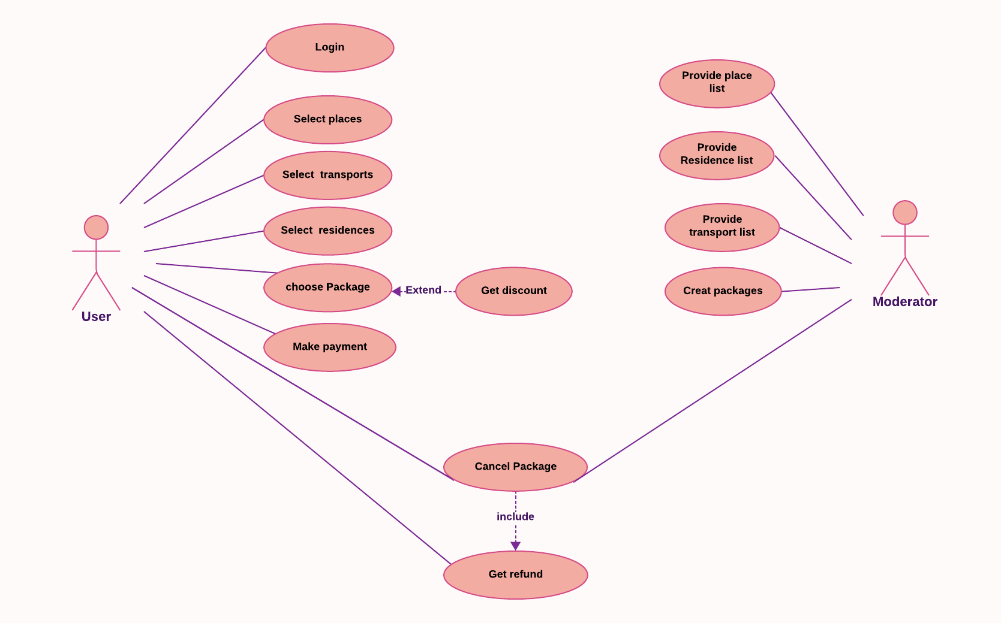

**Figure: Use Case Diagram for Tour and Travel Management System**

**For a detailed view copy this link and open in a browser:** <https://lucid.app/lucidchart/a4c5cd8d-ba8f-4d64-a8fd-7c7e9c9e001b/edit?viewport_loc=-1019%2C-81%2C3197%2C1300%2C0_0&invitationId=inv_8d3ef804-9cb1-4a65-a3f3-e59b31e2e055>

**Description of Use Case Diagram**

|  |  |
| --- | --- |
| **Use Case:** | Log in |
| **Actors:** | User |
| **Purpose:** | Log into the system |
| **Overview:** | Allow users to make an account in the system. |
| **Normal Flow:** | 1. User fills in the necessary information.  2. User sets a password.  3. User enters into the system. |

|  |  |
| --- | --- |
| **Use Case:** | Select place |
| **Actors:** | Travelers |
| **Purpose:** | The purpose of this use case is to allow travelers to select their desired travel destination when planning a trip. |
| **Overview:** | This use case enables travelers to specify where they want to go when booking a trip through a travel agency or online travel platform. |
| **Normal Flow:** | 1. Traveler starts a new trip booking process.  2. Traveler is prompted to select their travel destination |

|  |  |
| --- | --- |
| **Use Case:** | Select Transport |
| **Actors:** | Travelers |
| **Purpose:** | The purpose of this use case is to allow travelers to transportation for a trip. |
| **Overview:** | This use case enables travelers to specify how they want to get there when booking a trip through a travel agency or online travel platform. |
| **Normal Flow:** | Traveler chooses from available transportation options (e.g., flight, train, bus, car) |

## **3(d). Data Flow Diagram of Tour and Travel Management System**

**1. Context Diagram of Tour and Travel Management System:**

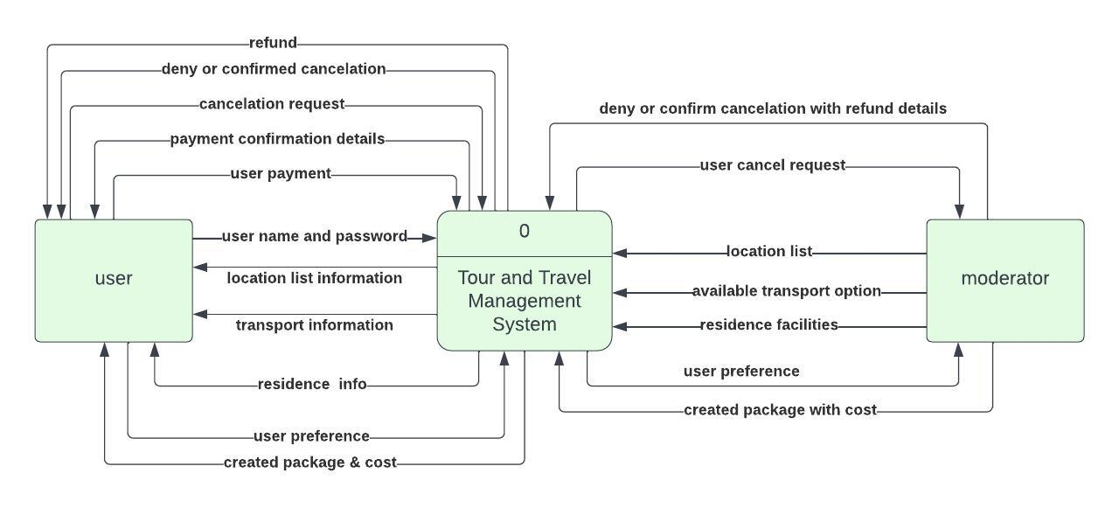

**Figure: Context Diagram of Tour and Travel Management System.**

**For a detailed view copy this link and open in a browser:** <https://lucid.app/lucidchart/44203ce6-7cc1-44b6-8004-bd42cf3d91c6/edit?viewport_loc=-82%2C-156%2C1365%2C609%2C0_0&invitationId=inv_5ccce682-029f-4cb0-b1f7-b0809a4ae5f6>

**2. 0 Level Data Flow Diagram of Tour and Travel Management System:**

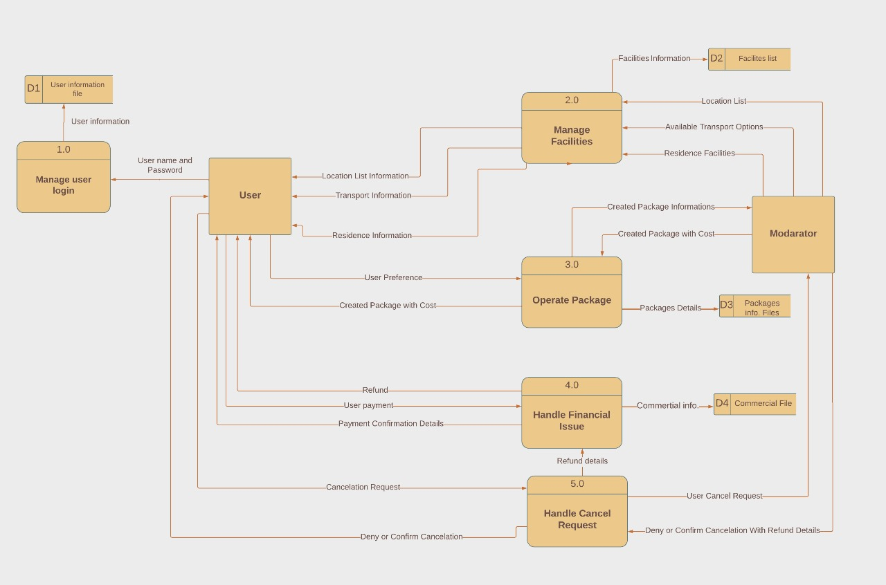

**Figure: 0 Level Data Flow Diagram of Tour and Travel Management System.**

**For a detailed view copy this link and open in a browser:** **<https://lucid.app/lucidchart/5a20ff24-2bf5-4d9f-8101-680ff0e239a4/edit?viewport_loc=-1896%2C-589%2C3813%2C1797%2C0_0&invitationId=inv_9a80a7f2-e4ff-48ab-a0fc-932a51bb187a>**

## **3(e).Entity-Relationship (E-R) Diagram of the Tour and Travel Management System**

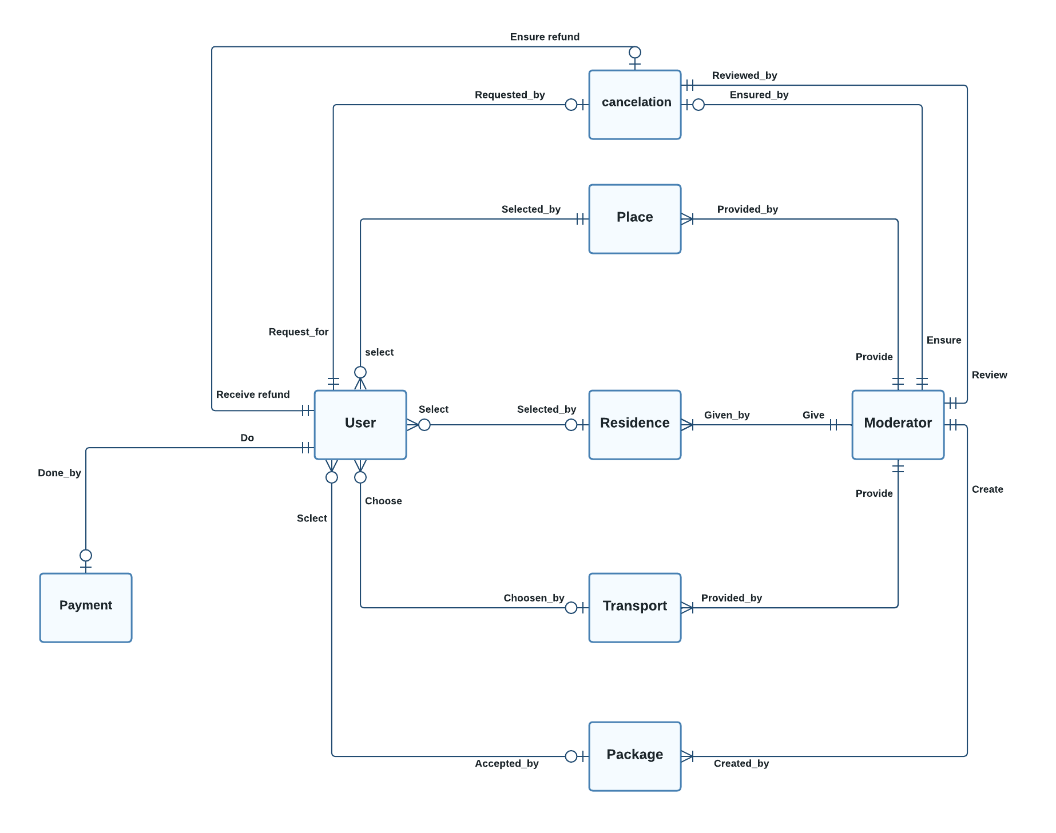

**Figure: Entity-Relationship (E-R) Diagram of Tour and Travel Management System.**

**For a detailed view copy this link and open in a browser:** **<https://lucid.app/lucidchart/4bc65373-cc96-4337-bd2a-58045a513f09/edit?viewport_loc=-1062%2C-419%2C3803%2C1546%2C0_0&invitationId=inv_ac8a418e-3487-42ca-aeb9-2bda6e690a19>**

## **3(f).Forms, Reports, and Interfaces with Narrative Overview of Tour and Travel Management System.**

1. **Welcome Pages**

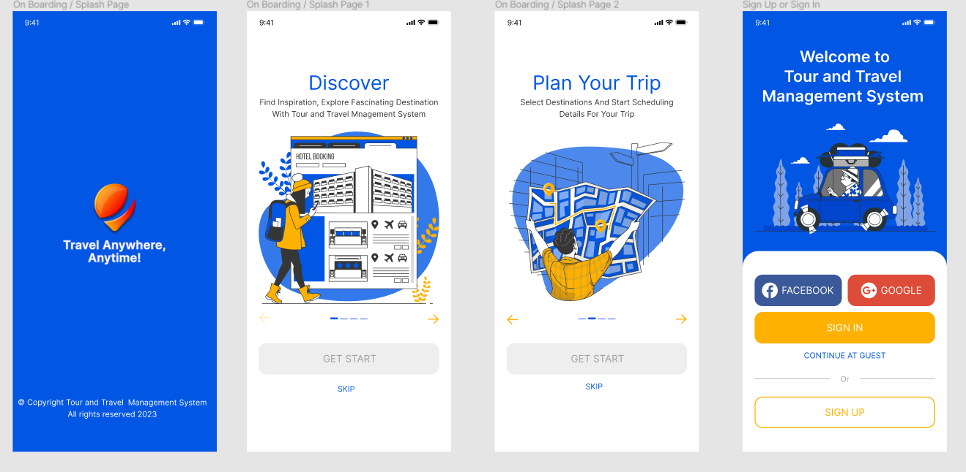

1. **Sign Up or Sign In**

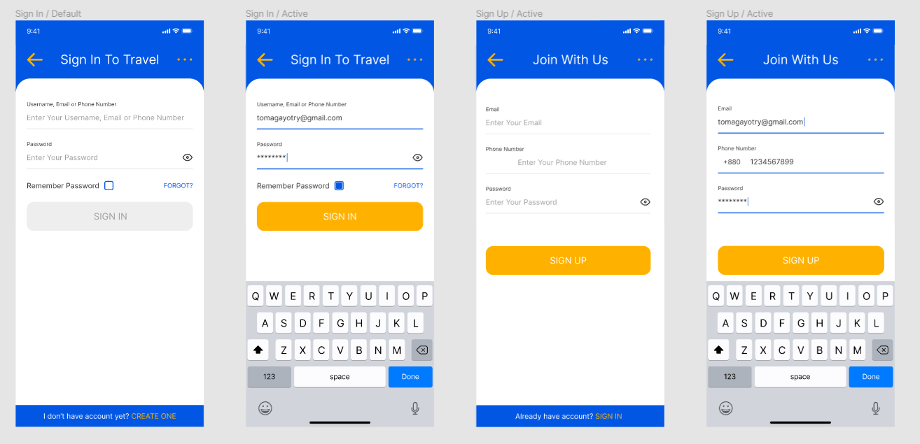

1. **Profile**

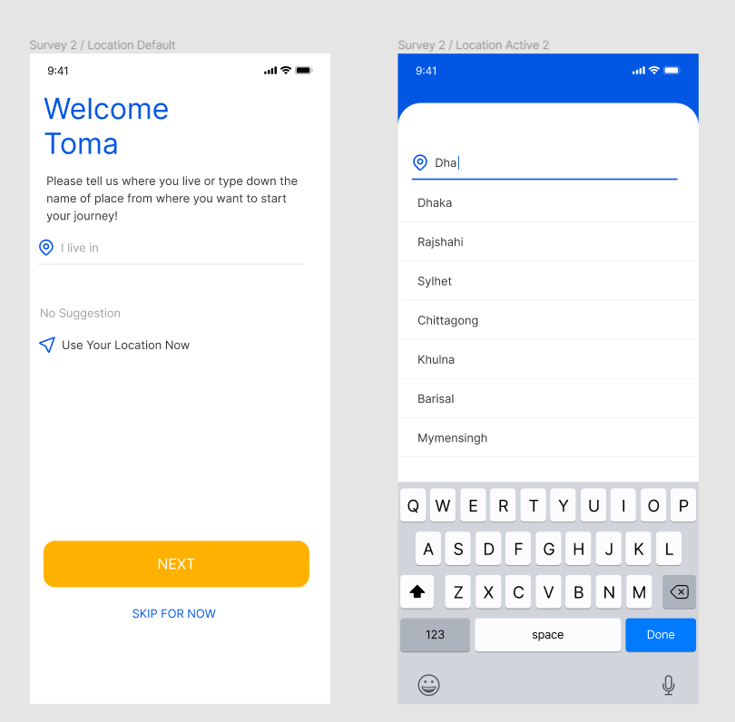

1. **Home Page**

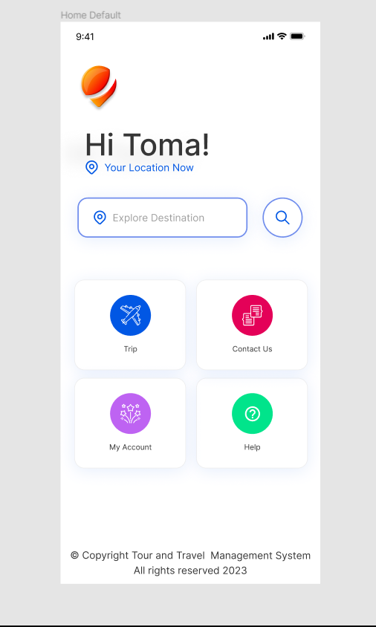

1. **Explore Destination**

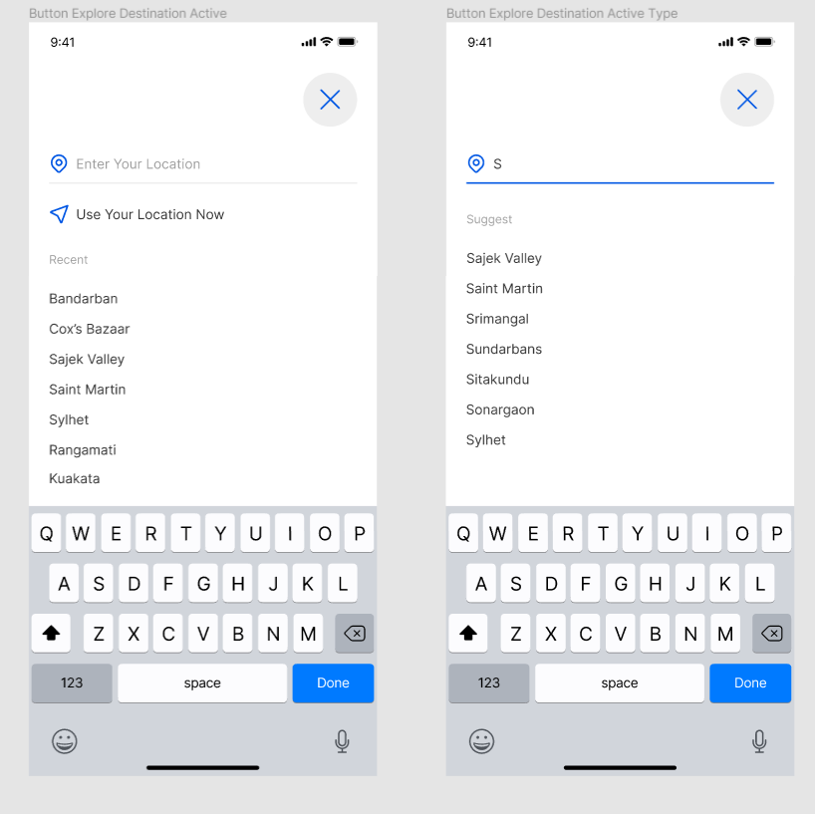

1. **Transportation**

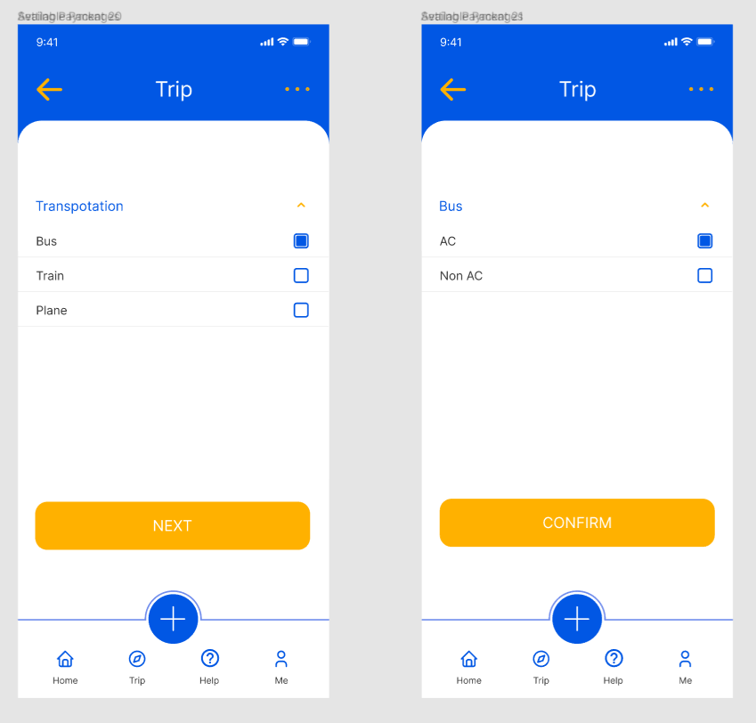

1. **Residence Booking**

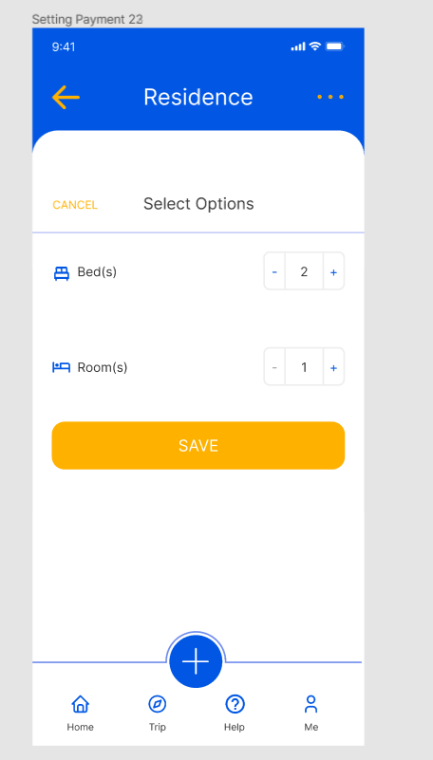

1. **Available Packages**

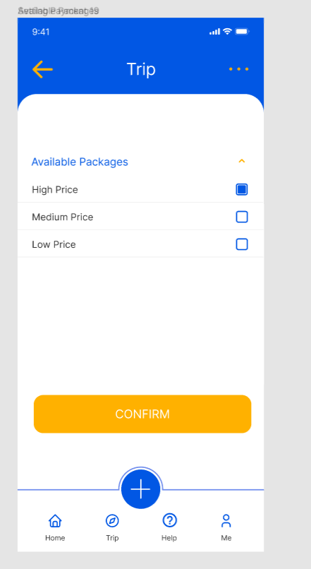

1. **Payment Method**

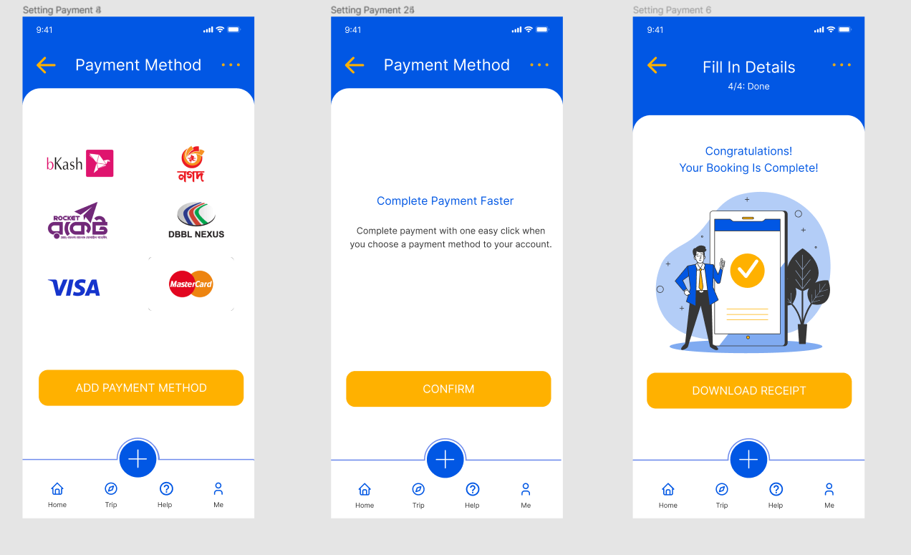

1. **Report**

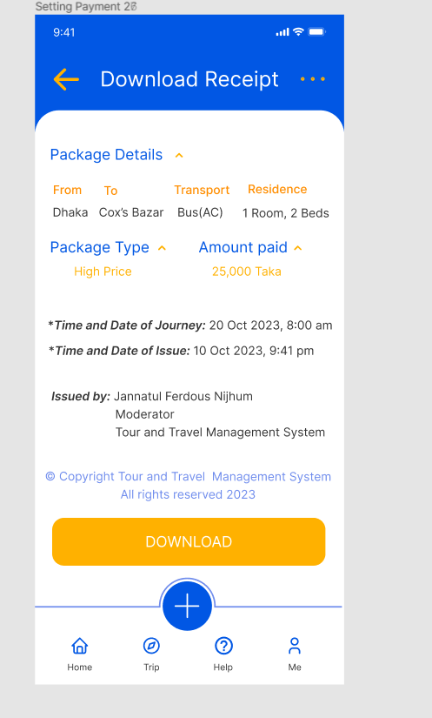

1. **Package Cancellation**

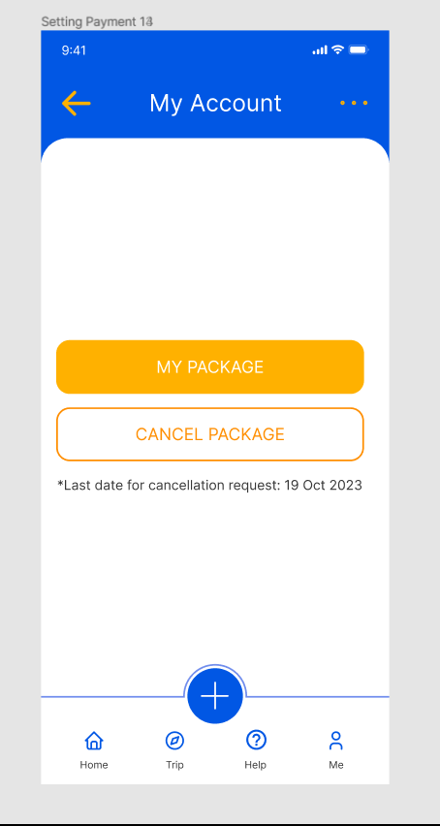

1. **Refund Request**

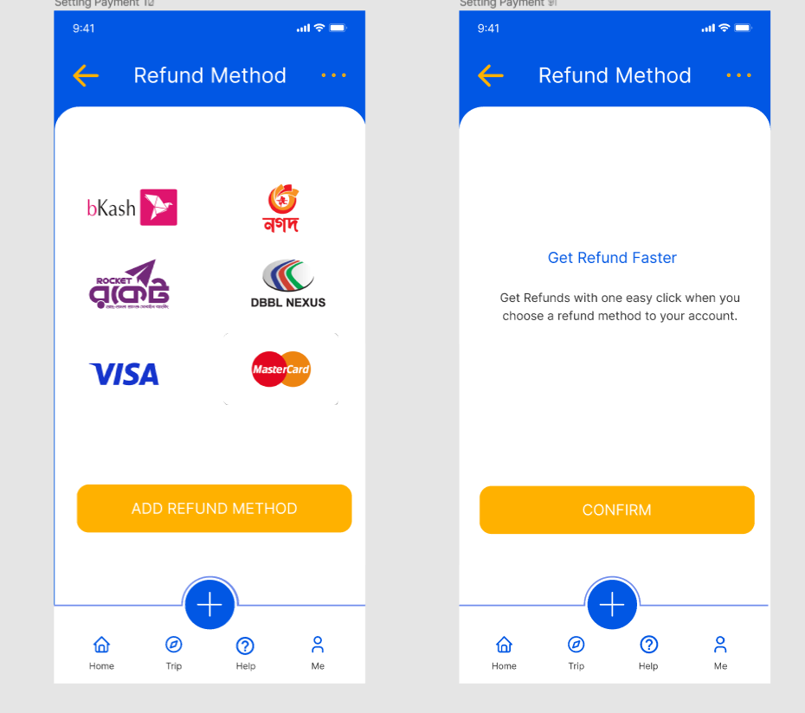

1. **Help and Contact**

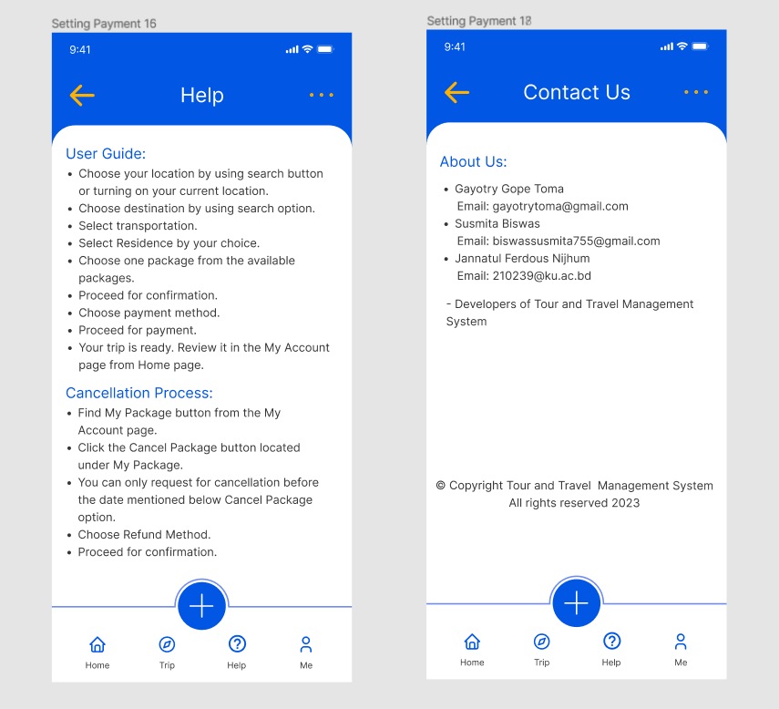

# **4. Feasibility Studies of Tour and Travel Management System**

## **4(a). Economic feasibility analysis & risks and tangible and intangible cost and benefits**

**One Time Cost Analysis:**

|  |
| --- |
| **One Time Cost Analysis Tour and Travel Management System** |
| **Year 0** |
| **1. Hardware:**  a. PC 62000.00৳  b. Monitor 15000.00৳  c. Network device 5000.00৳  d. Router 2000.00৳  e. Printer 10000.00৳  f. other materials 5000.00৳  **2. Development Cost:** 15000.00৳  **3. Service Cost:** 3000.00৳  **4. Site Visiting:** 2000.00৳  **5. Other costs:** 1000.00৳  **Total One Time Cost:** 120000.00৳ |

**Fig: One Time Cost Calculation of Tour and Travel Management System**

**Recurring Cost Calculation:**

|  |
| --- |
| **Recurring Cost Calculation Tour and Travel Management System** |
| **Year 1 to 5** |
| **1**. **Application Software Maintenance:** 30000.00৳  **2.Website Hosting:**  62000.00৳  **3. Incremental communications**: 8000.00৳  **Total Recurring Cost:** 100000.00৳ |

**Fig: Recurring Cost Calculation of Tour and Travel Management System**

|  |
| --- |
| **INTANGIBLE BENEFITS WORKSHEET**  **Tour and Travel Management System Project** |
| * Improved Brand Reputation * Time Savings * Scalability * Regulatory Compliance * Better Supplier Relationships * Data Security |

|  |  |
| --- | --- |
| **TANGIBLE BENEFITS WORKSHEET**  **Class Management System Project**  **Year 1 through 5** | |
| A. Cost reduction or avoidance  B. Error reduction  C. Increased flexibility  D. Increased speed of activity  E. Improvement in management planning or control  F. Improvement in communication | 40,000  15,000  20,000  30,000  25,000  50,000 |
| **Total tangible benefits** | **180,000** ৳ |

|  |  |
| --- | --- |
| **Class Management System Risk Factors** | |
| Project Size | As the project is quite large, the number of members in the project team, the duration of development, the number of organizational departments involved in the project, size of programming effort (e.g., hours, function points) & number of outsourcing partners will be large too. As a result, the project is a bit risky. |
| Development Group | A well-familiar group of people who have quite an expertise in the development platforms will be working on the project. So, the risk factor is quite low. |
| User Group | The key users are not familiar with using this kind of system. So, it may be risky at all. |

**Economic Feasibility Analysis**

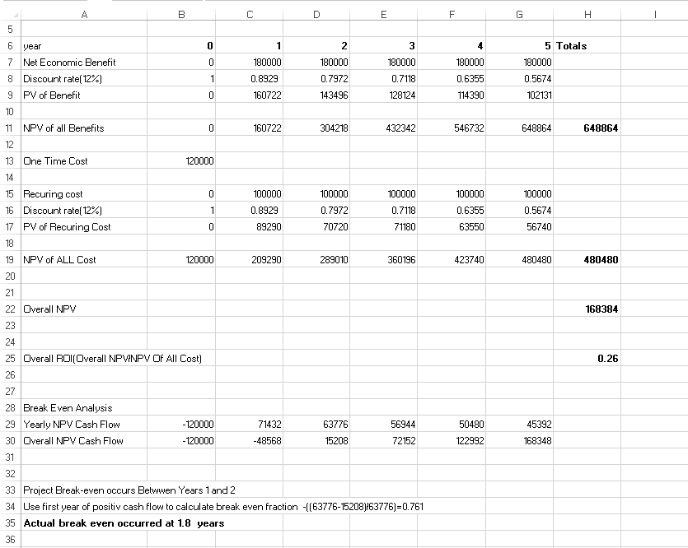

**Break-even point on a 2D graph:**

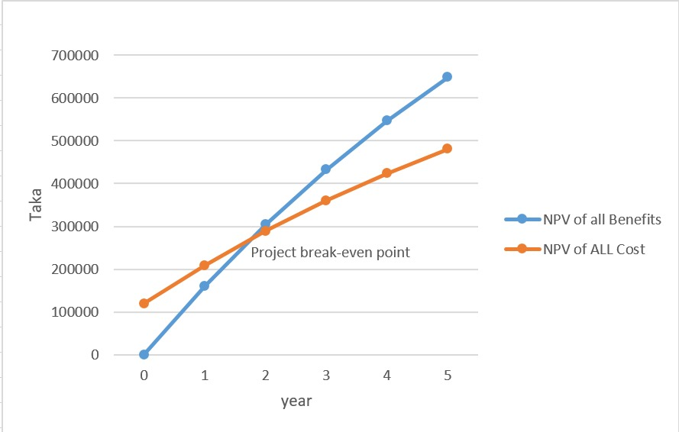

**The intersecting point shows the break-even point**

# 5**. Management Procedure & methodology of Tour and Travel Management System**

# Our IS development and management team suggests using the Evolutionary methodology for building our Tour and Travel Management System. This method combines aspects of both traditional Waterfall and Agile approaches, making it suitable for our large-scale project where requirements may evolve and user feedback is crucial. It allows us to develop the system incrementally, adjust to changing needs, and backtrack if necessary, ensuring a flexible and user-focused development process.

1. **Project Charter of Class Management System**

|  |  |  |  |  |
| --- | --- | --- | --- | --- |
| **Project Charter** | | | | |
| **Project** | **Tour and Travel Management System** | | | |
| **Created By** | **Jannatul Ferdous Nijhum** | **Date** | | 15.09.23 |
| **Phone** | **01571021879** | **Email** | | [210239@ku.ac.bd](mailto:210204@ku.ac.bd) |
| **Mission** | This project is for making the current offline system of Tour and Travel management system online. Besides the current features provided by this organization, new and improved features can be introduced by this project.  1. To build up a system that gives information identifying specific places.  2. To perform their tour more comfortably having no worry of booking hotel, managing transportation ticket etc.  3. To enhance efficiency and convenience, allowing individuals to save valuable time and energy. | | | |
| **Objectives** | By replacing this with an online comprehensive platform the organization can expand its network through all over the country. Our vision is to make a permanent platform to create a hassle-free touring experience by handling various aspects, such as hotel reservations and transportation ticket management, ensuring that travelers can enjoy their journeys with ease. | | | |
| **Deliverables** | 1. Comprehensive travel management system. 2. Online community for travelers. 3. Secure payment options. | | | |
| **Stakeholders** | **Project Management Team:**  Susmita Biswas,Gayotry Gope Toma  **Sponsor:** Jannatul Ferdous Nijhum  **Mobile: 01571021879**  **Email:** [210239@ku.ac.bd](mailto:210204@ku.ac.bd) | | | |
| **Communications** | **Main channels of communication:**  Google Collab, G-mail, Team Meet Up. | | | |
| **Documentation** | **Project Manager:**  Tour and Travel Management System acts as a dynamic work management software tailored for the travel industry. This system synchronize seamlessly, ensuring that everyone involved stays informed and aligned and productivity in the tour and travel management process. | | | |
| **Signatures** | **Project manager** | | **Sponsor** | |

# **7. Project Schedule with activity list, Gantt chart, and network diagram of Class Management System**

## **7.1 Activity list**

|  |  |  |  |
| --- | --- | --- | --- |
|  | | **ACTIVITY LIST** | |
| PROJECT NO. | 00001 |  | **FULL PROJECT NAME:** |
| **Tour and Travel Management System** |
| **DATE:** | 22/09/2022 |  | **PROJECT MANAGER:** |
| **Susmita Biswas** |
|  | |  | |
| **ACTIVI**TY**LIST** | |  | **ACTIVITY ATTRIBUTES** |
| **Activity No.** | **Activity Name** | **Date** | **PREDECSSOR ACTIVITY IDs** |
| **1** | Defining Requirements | 08/02/2023 | N/A |
| **2** | Interview | 08/02/2023 | N/A |
| **3** | Designing Interview Form | 08/02/2023 | N/A |
| **4** | Schedule Appointments | 08/03/2023 | 3 |
| **5** | Conduct Interview | 08/06/2023 | 4 |
| **6** | Review Current Reports | 08/03/2023 | 1 |
| **7** | Collect Reports | 08/02/2023 | N/A |
| **8** | Review Reports | 08/06/2023 | 7 |
| **9** | Summarize Results | 08/08/2023 | 5, 8 |
| **10** | Project Initiation | 08/09/2023 | N/A |
| **11** | System Service Requset | 08/09/2023 | N/A |
| **12** | Project Charter | 08/09/2023 | N/A |
| **13** | Feasibility Analysis | 08/10/2023 | 1 |
| **14** | Economic  Feasibility | 08/10/2023 | N/A |
| **15** | Management  Plan | 08/14/2023 | 10 |
| **16** | Task  Responsibility  Matrix | 08/14/2023 | N/A |
| **17** | Communication Matrix | 09/14/23 | N/A |
| **18** | Dialogue & Interface Design | 0815/2023 | N/A |

**Gantt chart:**

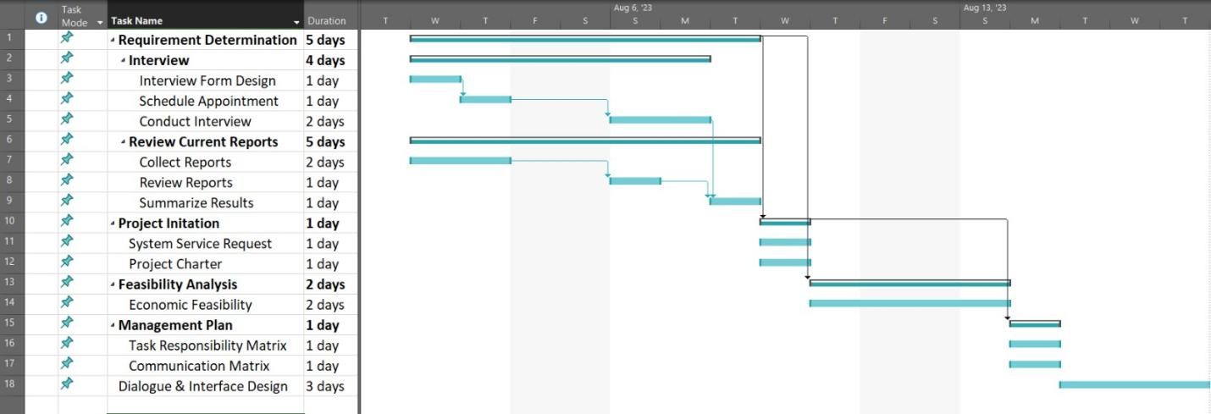

**Network Diagram:**

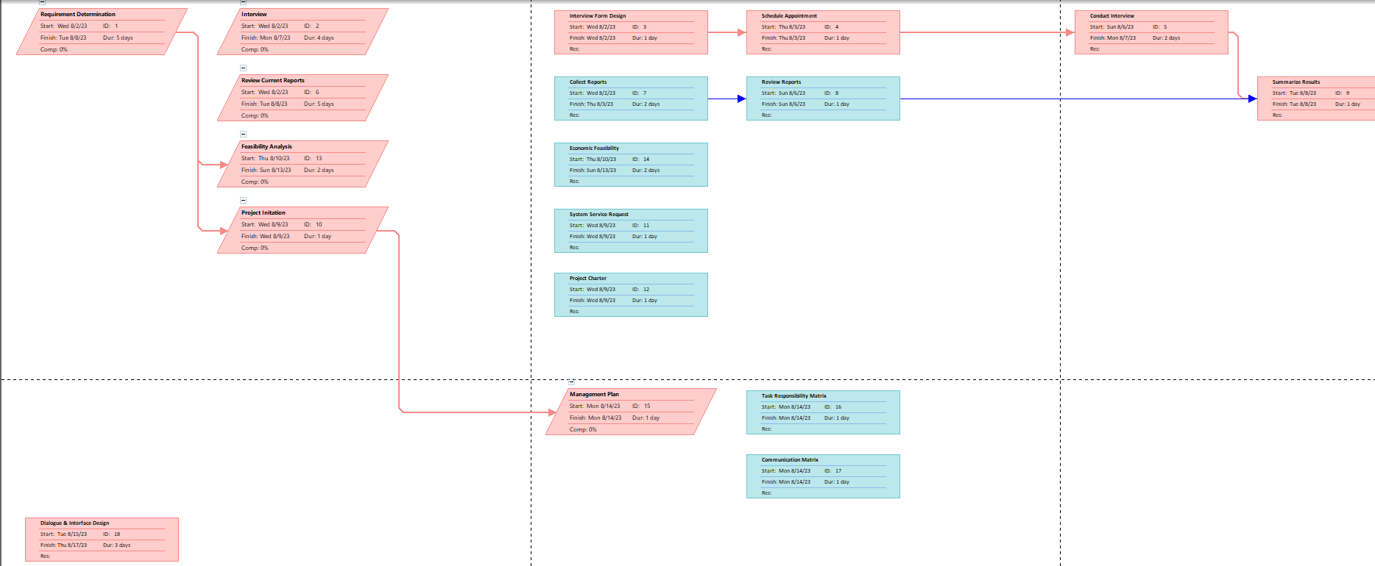

# **8. Business Documents**

In this project, we have collected some business documents that can give us an idea about the current system. The business documents are the following:

**Payment Slip of The Travel Agency:**

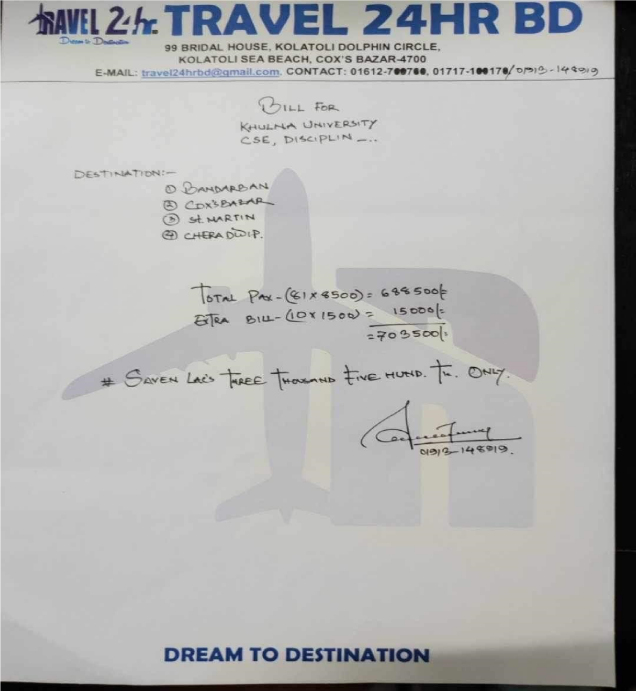

**Tour Plan of the user:**

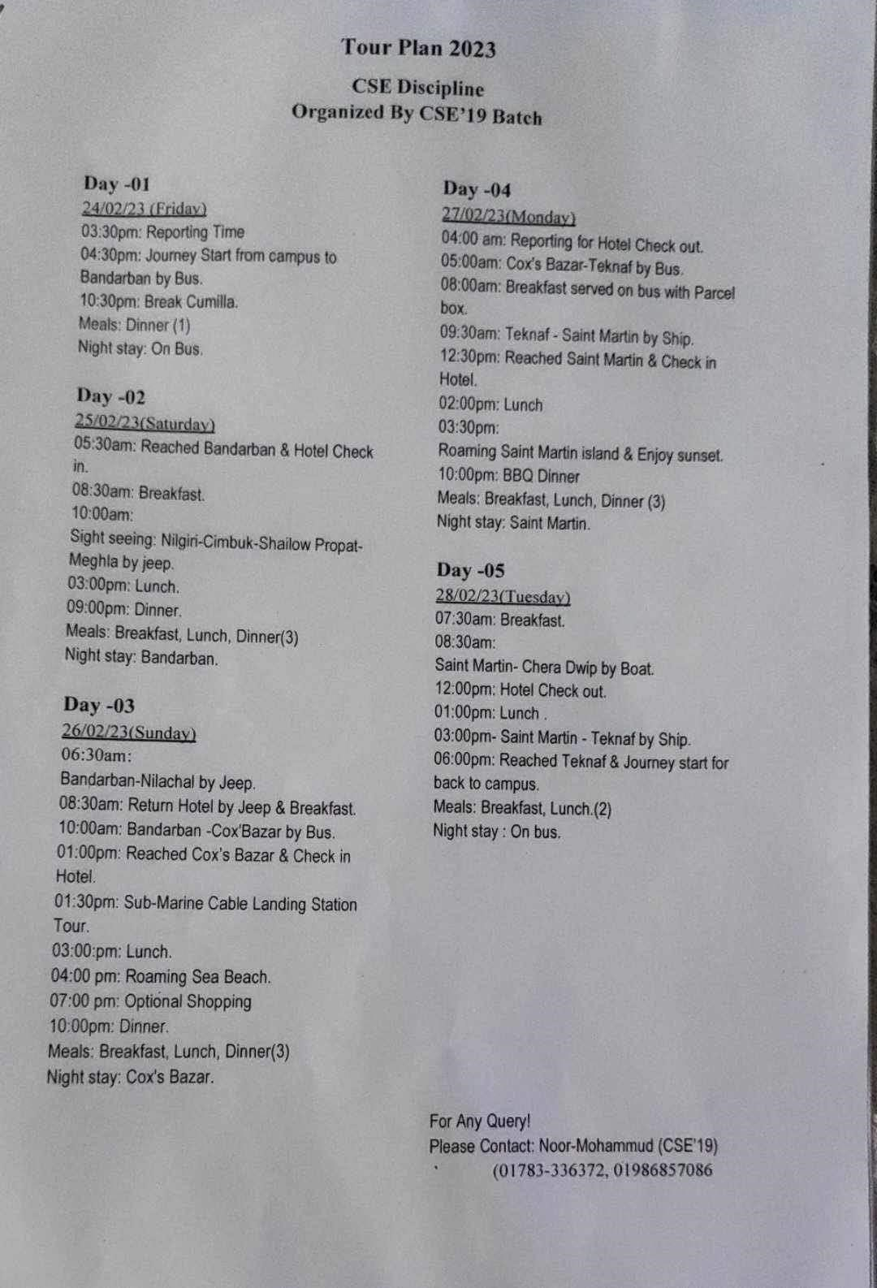

**Advertisement by the Tour Travel Agency:**

